Year 8 Term 1 Revision

- A) Explain the difference between physical and chemical changes, and give two examples of each.
- Explain how can you identify if a change is a physical or a chemical change has occured?
- List the first 20 elements of the periodic table. Write the name and chemical symbol for each.
3. Define the terms ATOM, ELEMENT, COMPOUND, MIXTURE, MOLECULE and list two examples of each.
4. Using the following symbols: A = , B = , and C = , draw a diagram to represent:
a) an atom of element B
b) a molecule of a compound containing A and B
c) a molecule of element C
d) a molecule of a compound of A and C
H
H
H
H
C
5. a) Is the diagram on the right showing an element or a compound? Justify your answer.
b) Is the diagram on the right a molecule or not? Justify your answer.
c) Is the diagram on the right showing a pure substance or a mixture? Justify your answer
d) Write the formula for the substance shown on the right:

6. Identify the general location of METALS and NON-METALS
on the periodic table, and list 3 examples of each.
7. Explain why some elements have a symbol that is very different to its name. For example, Iron is Fe.
COMPOUND | FORMULA | a. List the elements that make up:  i. Ammonia  ii. Cane Sugar  b. State which compound would have the largest molecules.  c. State which compounds contain Carbon.  d. State the number of oxygen atoms in three molecules of Iron oxide.  e. Identify the compound from which you could extract the element sodium.  f. Which compound has the most hydrogen atoms? (bit if a trick question)
Alcohol  Ammonia  Cane sugar  Carbon dioxide  Hydrochloric acid  Iron oxide  Sodium chloride  Water | C₂H₅OH  NH₃  C₁₂H₂₂O₁₁  CO₂  HCl  Fe₂O₃  NaCl  H₂O
8. Use the table below to answer the questions that follow:

9. Identify which picture below best represents:
a) atoms of an element d) molecules of a compound containing three atoms
b) molecules of an element e) a mixture of elements
c) molecules of a compound made of 2 elements f) a mixture of compounds
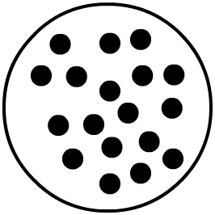
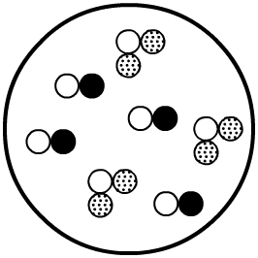
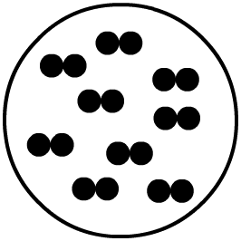
I II III

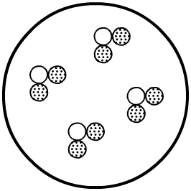
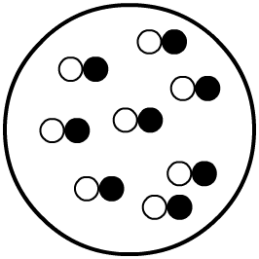
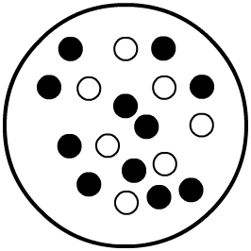
IV V VI

10. List the four (4) indicators that a chemical change has taken place.
11. Complete the table below about solutions, colloids and suspensions:
FEATURE | SOLUTION | COLLIOD | SUSPENSION
Particle size
Can particles be seen?
Does light pass through, or is it scattered?
Is it Transparent,
Translucent or Opaque?
Can particles be filtered out?
Does it separate into layers over time?
Examples

12. List some properties of a material that would be suitable for making a skateboard deck. Identify which would be the two most important properties of the material, and justify why you think these are the most important properties needed.

